Appendix A1: User Interfaces
In this part, we describe all the GUIs (graphical user interfaces) of IA. Their Screen shots along with functions are discussed below.

1.1 Form frmLine
This form appears at startup of the application and remains active till the end of the application. It hold the information which includes Line and Phone status (Idle, Connected, Busy, Disconnected). This form also detect DTMF signals (touch tones) from the Phone calls and keys from Door interface.

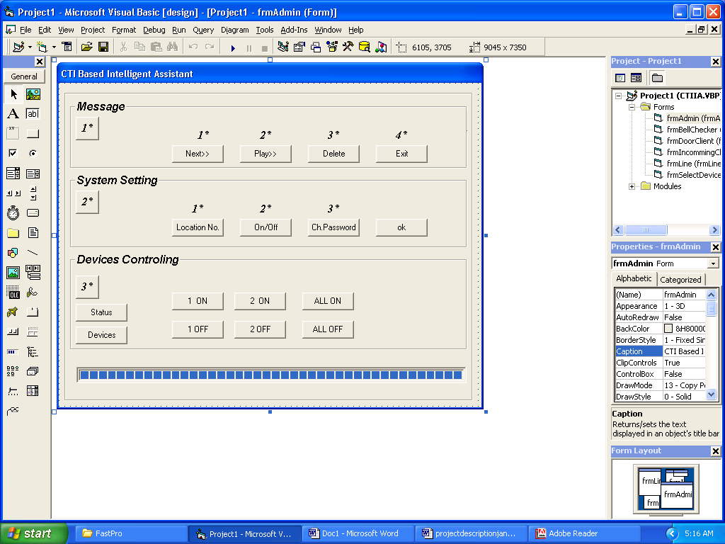
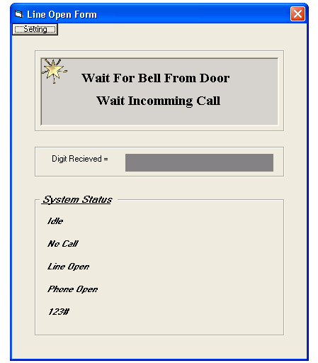
Figure 1: frmLine
1.2 Form frmBellChecker
This form waits for detection of a call or door bell signal. Any of the event occurs, the form will dispose, and perform related activity.
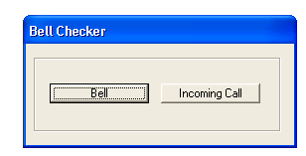
Figure 2: frmBellChecker

1.3 Form frmSelectDevices
This form helps in selection of devices i.e
- Play and Records devices to play and record the wave file at Door interface.
- Line device to Play and Record the wave file on Phone line.
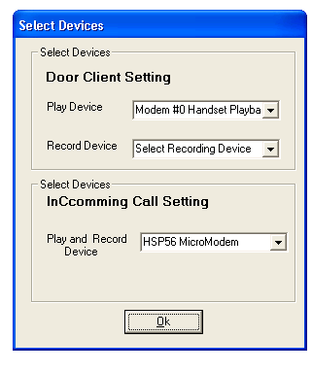
Figure 3: frmSelectDevices
1.4 Form frmDoorClient
This form serves the Door client. When Client Press Bell, system activates and starts voice messages which are so much explanatory such that it helps to guide the client completely..
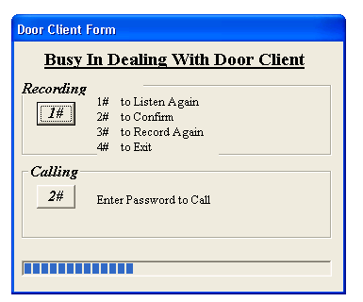
Figure 4: frmDoorClient

1.5 Form frmIncommingCall
This form serves the person who is call on the Phone line. When any call come, system activates and sarts voice messages over a phone line which are so much explanatory such that it helps to guide the client completely..
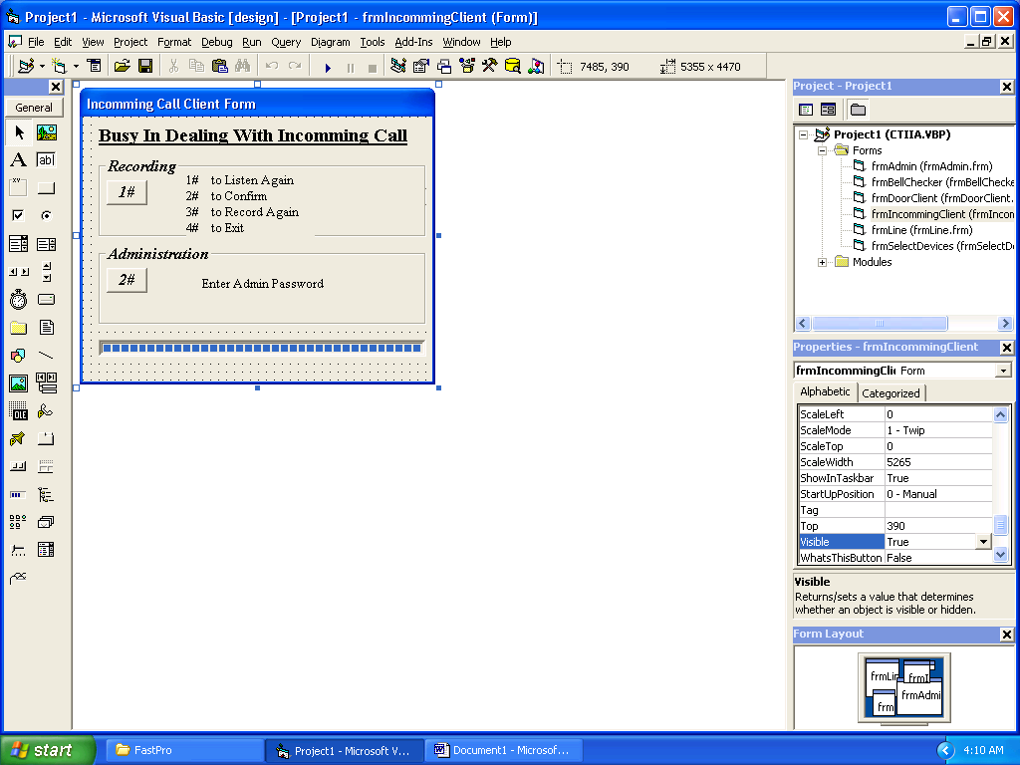
Figure 5: frmIncommingCall
1.6 Form frmAdmin
It is an Administration form which serves the administrator or system owner to control his IA from any remote location out side the home. Three main options are provided for administration.
- Message Administration Service.
- System Settings Configuration.
- Controlling the Electrical Devices.

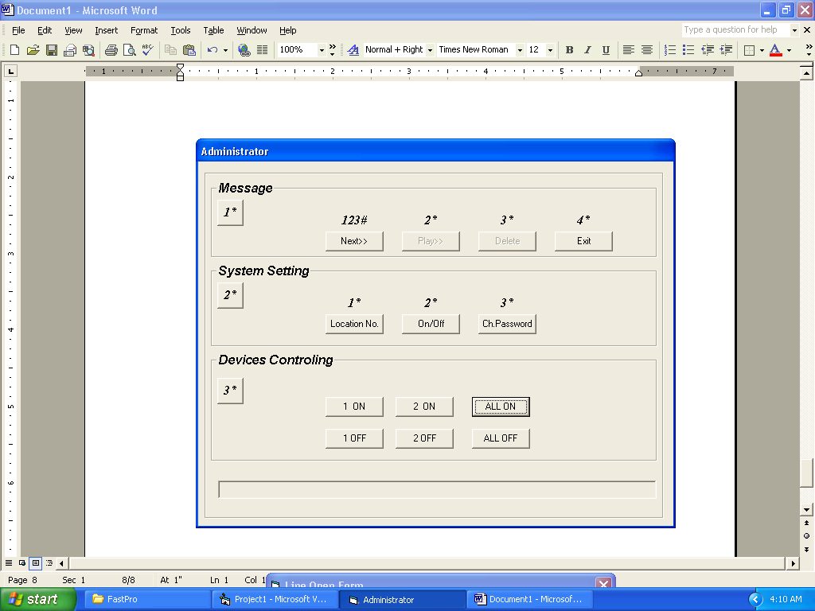
Figure 6: frmAdmin

Appendix A2: Installation Guide and User Manual
Before run the application, you must be configure some settings. Following are the steps which guide you better.

- Run Setup of amTapiPro ActiveX control Trail version.
- Run Setup of amWavePro.ocx ActiveX control Trail version
- Run Setup file of IAProject.
- Connect the hardware power supply (12V, 5V).
- Supply 220V to device controlling circuit.
- Connect Printer port with the connector provided with the output of microcontroller.
- Attached any two electrical devices with device controlling circuit. Its up to you.
- Run the software application.
- Set the Line and Phone Devices. (see fig. 3 in appendix A1)
- The application is ready to use.

Appendix A3: TSP Capabilities

To run this application, your TSP must support the features which are listed with support equals ‘Yes’. All these capabilities are the requirement of amTapi.
.
Media Mode Capabilities: Supported
Automated Voice Yes
Interactive Voice -
Data Modem -
G3 Fax -
G4 Fax -

General Capabilities: Supported
Caller ID -
Monitor DTMF Digits Yes
Monitor Silence -
Set Terminal Mode -
Passthrough Mode -
Blind Transfer -
Hold/Unhold -
Generate DTMF Digits Yes
Dial On Existing Call Yes
Wave Input ID Yes
Wave Output ID Yes
Wave In/Out ID Not Necessary
Phone Capabilities: Supported
Ring Modes -
Buttons -
Handset -
Handset: Off -
Handset: Mic -
Handset: Speaker -
Handset: MicSpeaker -
Handset: Hookswitch Yes
Handset: Volume -
Handset: Gain -
Headset -
Speaker Phone Yes
Speaker Phone: Off -
Speaker Phone: Mic -
Speaker Phone: Speaker -
Speaker Phone: MicSpeaker Yes
Speaker Phone: Hookswitch Yes
Speaker Phone: Volume -
Speaker Phone: Gain -
Phone Input ID -
Phone Output ID -
Phone In/Out ID -

